Siddhesh Singh

23070521150

Lab 8

PL/SQL Procedure for Fund Transfer

# Step 1: Create Database Tables

## Create accounts Table

CREATE TABLE accounts ( account_no NUMBER PRIMARY KEY, holder_name VARCHAR2(100),

balance NUMBER(10,2) CHECK (balance >= 0)

);

## Create transactions Table

CREATE TABLE transactions (

transaction_id NUMBER GENERATED BY DEFAULT AS IDENTITY PRIMARY KEY,

from_account NUMBER, to_account NUMBER, amount NUMBER(10,2),

transaction_date TIMESTAMP DEFAULT SYSTIMESTAMP

);

# Step 2: Insert Sample Data

INSERT INTO accounts VALUES (101, 'Alice', 5000.00); INSERT INTO accounts VALUES (102, 'Bob', 3000.00); COMMIT;

# Step 3: Write PL/SQL Procedure

CREATE OR REPLACE PROCEDURE transfer_funds( p_from_acc NUMBER,

p_to_acc NUMBER, p_amount NUMBER

#### CREATE OR REPLACE PROCEDURE is used to either 1. Create a new procedure or 2. Replace the data if the procedure by the same name already exists

#### Here NUMBER specifies the data type as number as we are talking about payments

#### ) AS

v_balance NUMBER;

BEGIN

SELECT balance INTO v_balance FROM accounts WHERE account_no = p_from_acc; Here SELECT selects data from database

INTO specifies in which variable/database to look for

WHERE specifies which row’s data to select here where account no. equals to the payment from account

IF v_balance < p_amount THEN

RAISE_APPLICATION_ERROR(-20001, 'Insufficient balance.'); END IF;

IF THEN is the conditional keyword pair which does what’s written if the condition specified is true

Here it is to raise error if the payment amount exceeds the sender’s balance

END IF specifies that the IF statement is closed here

-- Deduct amount from sender

UPDATE accounts SET balance = balance - p_amount WHERE account_no

= p_from_acc; UPDATE keyword is used to edit/update/change the data where data was already inserted; that’s how it is different from INSERT

-- Add amount to receiver

UPDATE accounts SET balance = balance + p_amount WHERE account_no

= p_to_acc;

-- Log transaction

INSERT INTO transactions (from_account, to_account, amount) VALUES (p_from_acc, p_to_acc, p_amount);

INSERT is used to insert data in the rows mentioned and  VALUES specify their value

-- Commit transaction COMMIT;

DBMS_OUTPUT.PUT_LINE('Transfer successful.'); Prints the OUTPUT successfully

#### EXCEPTION specifies the exception (errors and how to handle them)

WHEN NO_DATA_FOUND THEN

RAISE_APPLICATION_ERROR(-20002, 'Invalid account number.');

#### WHEN OTHERS THEN ROLLBACK;

RAISE_APPLICATION_ERROR(-20003, 'Transaction failed: ' || SQLERRM); SQLERM returns the last error

#### END;

/

Specifies the end of our program/queries

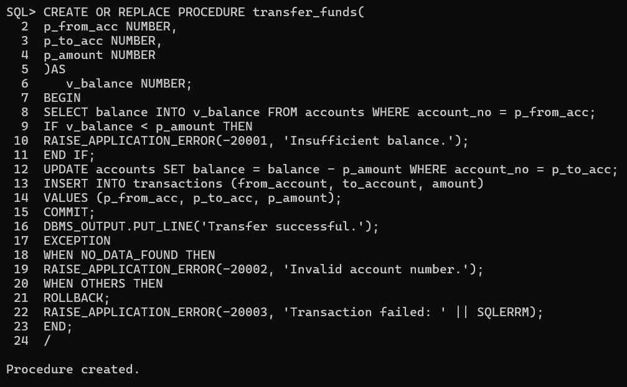

# Step 4: Execute Procedure

#### BEGIN

transfer_funds(101, 102, 1000); END;

/

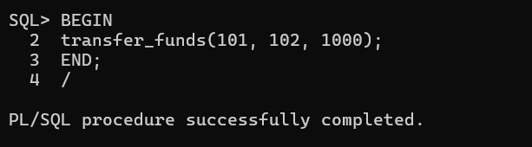

This block starts the procedure we created previously, with the required input.

# Step 5: Verify Results

## Check Account Balances

SELECT * FROM accounts;

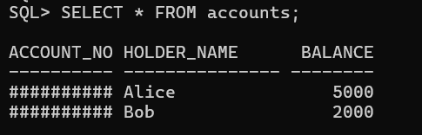

## Check Transactions Log

SELECT * FROM transactions;

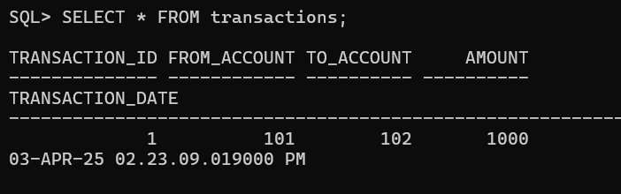

**Task: Fund Transfer Validation and Execution**

**Task 1: Check Account Balance Before Transfer -** Write a PL/SQL block that takes an account number as input and displays the account balance.

**Hint:** Use SELECT balance INTO inside a PL/SQL block and DBMS_OUTPUT.PUT_LINE to display the balance.

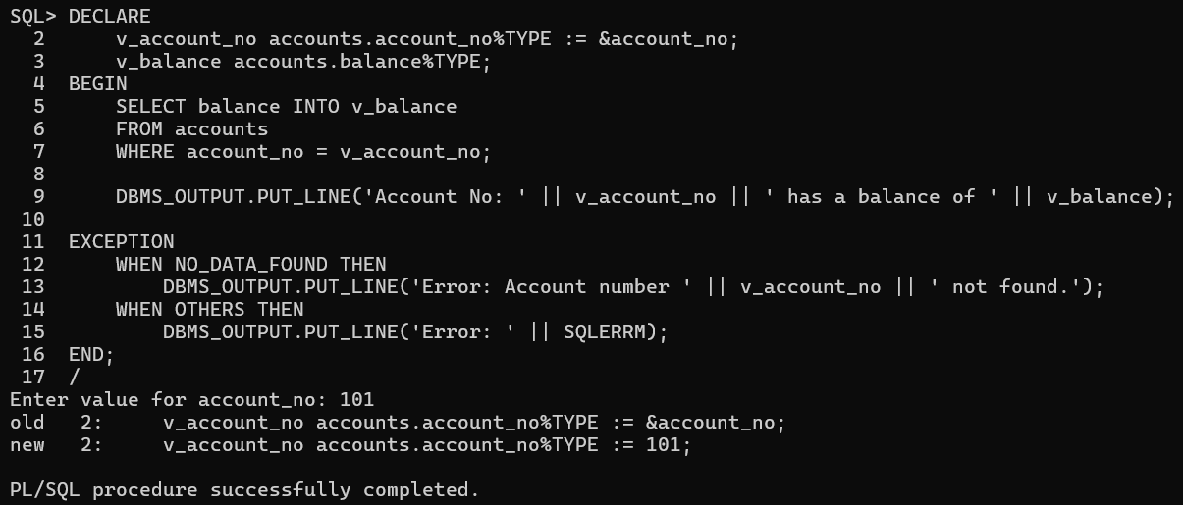

**Task 2: Execute Fund Transfer Procedure -** Call the transfer_funds procedure to transfer **₹500 from account 101 to account 102**.

**Hint:** Use the BEGIN...END; block to execute the procedure.

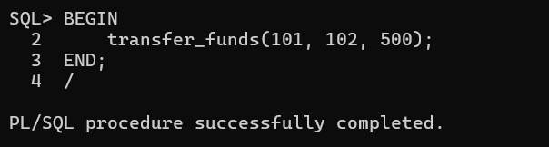

**Task 3: Validate Transaction Log -** After executing the transfer, write an SQL query to display all transactions recorded in the transactions table.

**Hint:** Use SELECT * FROM transactions; to verify the transaction details.

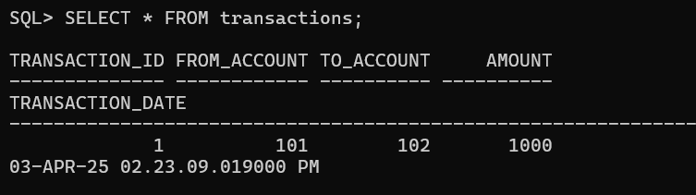

### Task 4: Check Transaction History for a Specific Account

Write a PL/SQL block that takes an account number as input and displays all transactions (both sent and received) related to that account.

**Hint:** Use SELECT * FROM transactions WHERE from_account = acc_no OR to_account = acc_no; inside a PL/SQL block.

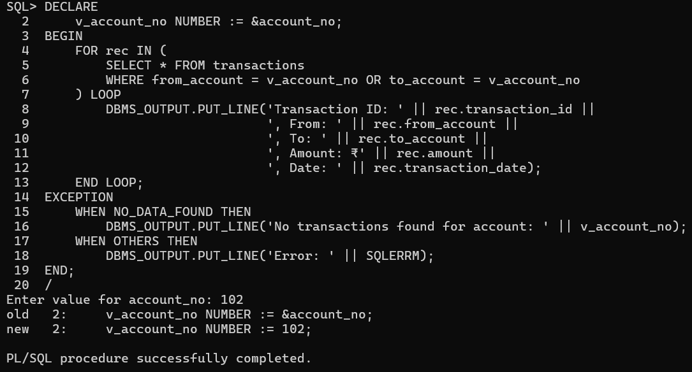

### Task 5: Prevent Self-Transfer

Modify the transfer_funds procedure to prevent an account from transferring money to itself. If the sender and receiver accounts are the same, raise an error message.

**Hint:** Add a condition inside the procedure:

IF p_from_acc = p_to_acc THEN

RAISE_APPLICATION_ERROR(-20004, 'Sender and receiver cannot be the same.');

END IF;

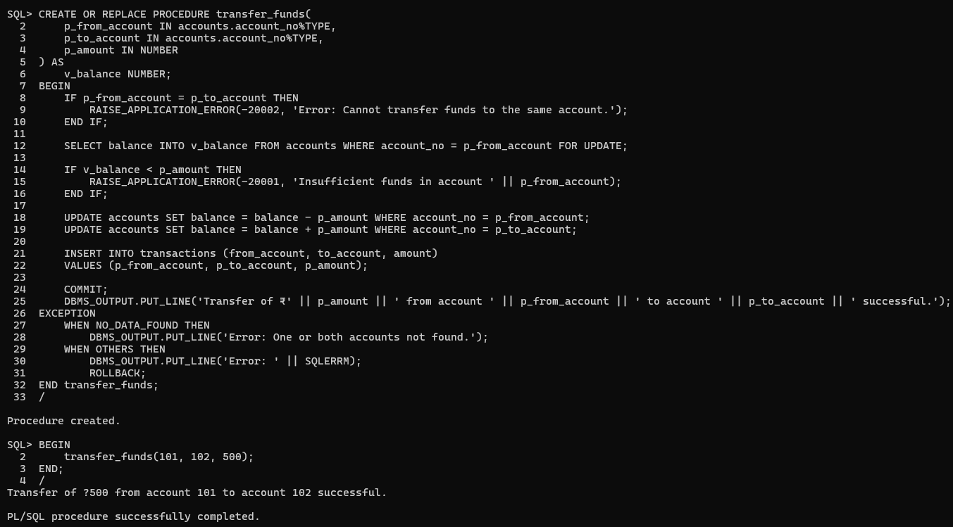

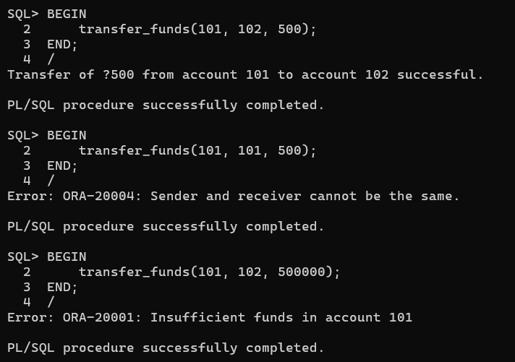

### Task 6: Create a Function to Check Account Balance

Write a PL/SQL function named get_balance that takes an account number as input and returns the current balance.

### Hint:

CREATE OR REPLACE FUNCTION get_balance(p_acc_no NUMBER) RETURN NUMBER AS

v_balance NUMBER; BEGIN

SELECT balance INTO v_balance FROM accounts WHERE account_no = p_acc_no;

RETURN v_balance; END;

/

Call it using:

SELECT get_balance(101) FROM dual;

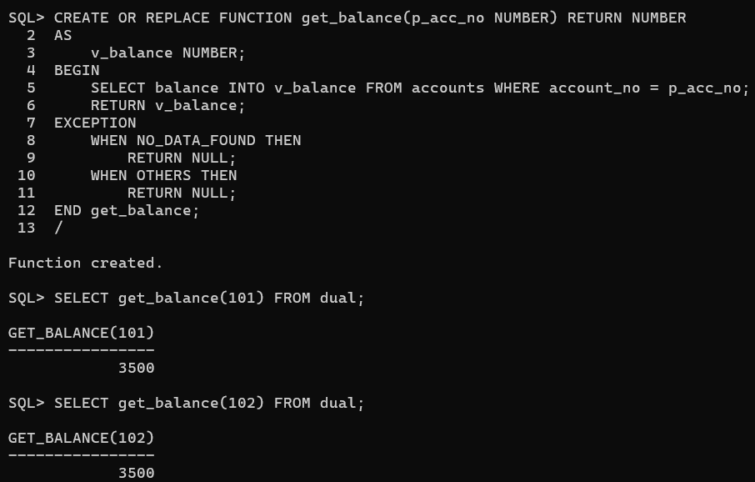

### 

### Task 7: Implement a Transfer Limit

Modify the transfer_funds procedure to set a maximum transfer limit of ₹10,000 per transaction. If a user tries to transfer more than this amount, raise an error.

**Hint:** Add a condition:

IF p_amount > 10000 THEN

RAISE_APPLICATION_ERROR(-20005, 'Transfer amount exceeds the limit of ₹10,000.');

END IF;

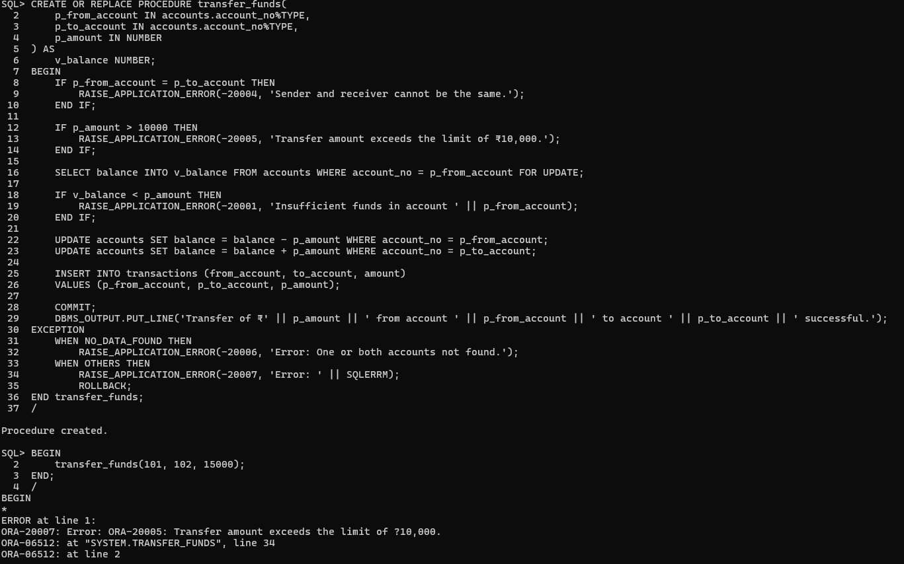

### Task 8: Generate a Monthly Statement

Write a PL/SQL procedure that takes an account number and a month-year (e.g., 04-2025) as input and displays all transactions for that month.

**Hint:** Use TO_CHAR(transaction_date, 'MM-YYYY') in the WHERE clause:

SELECT * FROM transactions

WHERE (from_account = acc_no OR to_account = acc_no) AND TO_CHAR(transaction_date, 'MM-YYYY') = '04-2025';

